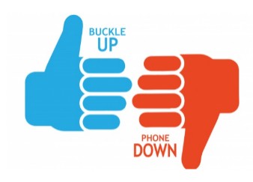

Company Buckle Up Phone Down Policy
Vehicle crashes continue to be a top cause of work-related injuries and deaths. Our company wishes to prevent vehicle crashes and associated injuries. Please do your part to make your work-related trip safer.

The company expects anyone driving any vehicle for company business to follow the safe driving expectations listed below.

These safe driving rules are basic expectations and should not be difficult for any driver to follow.

At any point noncompliance is discovered, documented corrective action will be taken.

Questions about this policy can be directed to your manager.

Thank you and please drive safely!
BUPD Safety Rules:
- Wear your seat belt whenever driving a vehicle for company business or whenever riding in a vehicle for company business. All passengers must wear seat belts.

- Do not drive distracted. Do not text and drive or manipulate a phone or any phone functions while driving. Avoid other prohibited distractions that can increase crash risks.

- Do not drive over the posted speed limit. Slow down when driving or traffic conditions deteriorate. Speeding is prohibited.

- Never report to work or drive while impaired. Impairment can be caused by prescription medications, alcohol consumption, aftereffects of illicit drug use, illegally used prescription medication, or any other legal medication or substance that makes driving a vehicle unsafe.

- Our company requires that driving employees sign the Buckle Up Phone Down pledge, available here: https://form.jotform.com/70314101030128. Management will assist you in completing this task.

Employee Signature:

Company Representative Signature:

Date of Policy Acknowledgement:

